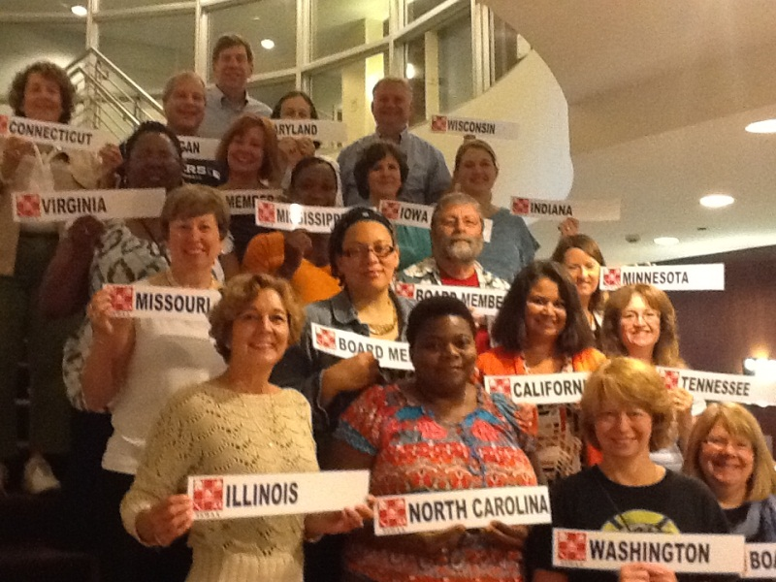
Delegate Assembly Report
August, 2012

We were pleased to represent our states at the School Social Work Association of America (SSWAA) Delegate Assembly on August 5,6,7 in Chicago, Illinois. There were several foci of the meeting. While ongoing organization of SSWAA and the structure of the Delegate Assembly (DA) process took up a lot of time, it appeared that these efforts were with the intent of supporting states in their ability to participate and to have participation be meaningful both to the states and SSWAA. Discussions included the role of the DA in other national associations, the role of SSWAA’s DA, how often the DA should meet, when should they meet, where should they meet, etc. These discussions demonstrated that SSWAA’s leadership is sensitive to the financial strains states face in attempting to support SSWAA as delegate states. A questionnaire will be coming to the boards of each state organization soon to seek out what will make membership most affordable and meaningful.

The next item of business included informing the delegates of SSWAA’s work at the national level. Many of us are aware of their annual conference and the Washington DC Leadership/ Legislative Institute each summer. However in addition, SSWAA currently is also working on four main projects. These include: 1. The development of a National Model for School Social work. 2. The development of standards to evaluate school social workers—currently based on the Danielson Model. 3. Linking school social work to educational and behavioral outcomes. 4. Developing a new website to provide increased resources School Social Workers and state associations.

There has been a committee working for some time on a National Model of School Social Work Practice. The Model was first presented during a workshop at the National Conference in Boston. The committee is proposing a mental health model utilizing a comprehensive and integrated services model to support academic and behavioral school performance.

There are four building blocks of the model: Home, School, and Community Linkages; Ethical Guidelines and Educational Policy; Educational Rights and Advocacy; and Data Based Decision Making. The pathways for implementation of the model include the provision of scientifically supported educational and mental health services; the promotion of school climate and culture conducive to learning; and maximizing school-linked and school-based resources. (Please see the draft of the model that includes additional details.)

Next steps in moving this project to fruition include the completion of the Executive Summary and then dissemination for public comment. It will be very important for people to review this model and provide comments regarding how this model defines our role. Stay tuned.
The DA also began work on updating some of the Resolution Statements and members will continue to work on those in order to present at the next DA.

Other work being done by SSWAA include development of a national research agenda, establishing a free webinar series, and providing current research links on relevant topics in our practice. SSWAA’s new website host also has the capability for state associations to collect membership dues by credit card for a nominal fee. Interested states will be able to link to their own on-line membership form. Credit card payments will be directly deposited into state’s bank accounts. After someone joins their state association, they will also be able to then access the reduced SSWAA Affiliate Dues of $95 (rather than $120). SSWAA is also working with the website host on establishing membership codes for states’ members who need to renew their membership at a later time after state dues are paid since most of us have various renewal dates over the year.

There was a lot of great discussion and energy throughout. Overall, Mollie Conrad, the DA for the state of Iowa, stated: “I was impressed with the energy that is occurring at the national level and was pleased to hear what our leadership is doing to develop and support our profession.”

Compiled from State Reports by Michelle Santiago, CA; Mollie Conrad, IA and Dot Kontak, MO.

